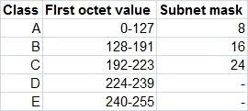

Based on the above image we give different subnet masks.

• 220.5.6.54

11111111. 11111111. 11111111.00000000

• 13.4.6.0

11111111. 00000000. 00000000.00000000

• 196.8.5.0

11111111. 11111111. 00000000.00000000

• 201.5.6.0

11111111. 11111111. 11111111.00000000

• 125.11.1.0

11111111. 00000000. 00000000.00000000

• 10.3.2.0

11111111. 00000000. 00000000.00000000

• 172.168.1.0

11111111. 11111111. 00000000.00000000

•192.12.8.0

11111111. 11111111. 11111111.00000000

• 226.4.6.128

There is no subnet address.

whereas the multicast address is

11110000.00000000.00000000.00000000

• 2.53.63.0

11111111. 00000000. 00000000.00000000